Cleveland Clinic (2008) Limited

Patient Access to Medical Records

and Subject Access Request Policy

Version: 2026.6
Dated: 05 JUNE 2026

Patient Access to Medical Records
and
Subject Access Request Policy

Version: | Review date: | Edited by: | Approved by: | Comments:
2024.1 | 24/01/2024 | SJR | SJR
2025.02 | 27/02/2025 | NMR | NMR
2026.06 | 05.06.2026 | NMR | NMR

Table of Contents
1. What Constitutes a Health Record? 6
2. Patient Access to Medical Records Policy 6
3. Fees 6
4. Which clinician should be consulted for information? 6
5. Verification and Validation 7
6. Identification 7
7. Denial or Limitation of Information 7
8. Former Patients Living Outside the Jersey 7
9. Parental Requests for Information pertaining to their Children 7
10. Complaints 8
11. Subject Access Request Process Map 8
12. Subject Access Request Form (Example) 9

Introduction

The Data Protection (Jersey) Law 2018 (DPJL) allow the right of the individual to request information held on their personal health record.

We are a controller for the purposes of the Data Protection (Jersey) Law 2018. This law provides a right for individuals to request access to their personal data which can include health information (often called a ‘subject access request’). In order to do this, we have procedures in-place that allow for retrieval and assimilation of this information.

This policy sets out our approach.

- What Constitutes Personal Data or Health Record?

Personal data is information which relates to an identifiable individual. A health record could include, and not exhaustively, hand-written clinical notes, letters between clinicians, lab reports, radiographs and imaging, videos, audio-recordings, photographs and monitoring printouts. Records can be held in both manual or computerised medias.

- Patient Access to Medical Records Policy

This scope of the DPJL and GDPR legislation includes the right of patients to request information on their own personal medical records. Requests for information under the legislation must:

- Be in writing (written or electronic) to the controller. In certain circumstances, verbal requests may be accepted where the individual is unable to put the request in writing (this must be noted on the patient health record);
- Where there is genuine and reasonable doubt about identity, be accompanied with sufficient proof of identity to satisfy the controller and to enable them to locate the correct information (where requests are made on behalf of another, the controller must satisfy themselves that correct and adequate consent has been given);

The controller will then check whether all the individual’s health record information is required or just certain aspects. For this purpose the use of a Subject Access Request Form may be advised.

There is no fee charged for a Subject Access Request, unless;

- Where an information request has been previously fulfilled, the controller does not have to honour the same request again unless a reasonable time-period has elapsed. It is up to the controller to assess what constitutes as reasonable and must document the decision-making.
- Requests for personal data/health records information should be recorded internally and fulfilled within 4 weeks (unless under exceptional circumstances – the applicant must be informed where a longer period is required). Information given should be in a manner that is intelligible to the individual.

- Fees

Data Subject Access Requests (View or Copy): Free of Charge

Third Party Requests (Copy of Records – Not Subject Access Request): £50.00 Fixed Fee

If the request is onerous or repeated then a fee may be charged, the applicant must be informed of this fee in advance of providing the information requested.

- Which clinician should be consulted for information?

The correct clinician to be consulted, where necessary, about an individual’s information should be:

- The clinician who is currently, or was most recently, responsible for the clinical care of the individual in connection with the information which is the subject of the request; or
- Where there is more than one such clinician, the one who is the most suitable to advise on the information which is the subject of the request.

- Verification and Validation
The controller should verify and validate the reason for the request, either through the information provided within the request itself or by contacting the data subject to validate the request.

This should also apply to Third Party (Legal/Insurance/Government/Police) Access Requests, for example perhaps only a period of a patient’s record is appropriate for an insurance claim rather than the complete record from birth.

- Identification

The Controller shall ensure appropriate verification of any data subject making a request under the DPJL. Where there is a genuine and reasonable requirement or where there is doubt as to the requester’s identity, formal proof of identity, such as a passport, driving licence, or other official documentation may be required. Each request will be considered on a case-by-case basis and, where required, verification requirements must be carefully considered and documented.

Whilst third Party Organisations (e.g. Legal/Insurance/Government/Police) are expected to have completed their own identity checks and have these held on file, the Controller remains responsible for being satisfied as to the requestors identity and authority before releasing any information.

- Denial or Limitation of Information

The controller may deny or limit the scope of information given where it may fall under any of the following:

- The information released may cause serious harm to the physical or mental health or condition of the individual or any other person, or
- The disclosure would also reveal information relating to or provided by a third person who has not consented to that disclosure unless:
- The third party is a clinician who has compiled or contributed to the health records or who has been involved in the care of the individual;
- The third party, who is not a clinician, gives their consent to the disclosure of that information;
- It is reasonable to disclose the information without that third party’s consent.

Inability to identify the data subject or their representative may also warrant a denial.

A reason for denial of information does not have to be given to the individual but must be recorded.

- Former Patients Living Outside the Jersey

Patients no longer resident in Jersey still have the same rights to access their information as those who still reside here and must make their request for information in the same manner.

Original health records should not be given to an individual to take abroad with them, however, the Practice may be prepared to provide a summary of the treatment given whilst a patient of the Practice resident in Jersey.

- Parental Requests for Information pertaining to their Children

Parents will normally have responsibility for accessing the health records of their children, however, care must be taken to obtain the consent of the child where necessary (16 and 17-year-olds are considered to be adults in relation to confidentiality, and their consent would be necessary). It is important to be aware that children between 13 and 16 who have capacity and understanding for decision-making should also have their confidentiality respected, however, they should be encouraged to involve parents and guardians in their healthcare matters where appropriate.

- Complaints

Cleveland Clinic (2008) Limited has procedures in place to enable complaints about access to personal data and health records requests to be addressed.

The following channels are used to manage and respond to any complaints regarding the access to personal data and health records at the Practice:

- Firstly, the Practice Manager or Clinician involved should arrange to have an informal meeting with the individual to try to resolve the complaint locally;
- If we are unable to resolve matters informally, a more formal investigation shall take place;
- If the issue remains unresolved, the patient should be informed that they have a right to make a complaint in accordance with the Practice Complaints Policy.

Sometimes the patient may not wish to make a complaint through the Practice Complaints Procedure and instead, take their complaint direct to the Jersey Office of the Information Commissioner (JOIC) if they believe the Practice is not complying with their request in accordance with the DPJL. Alternatively, the patient may wish to seek legal independent advice.

- Subject Access Request Process Map
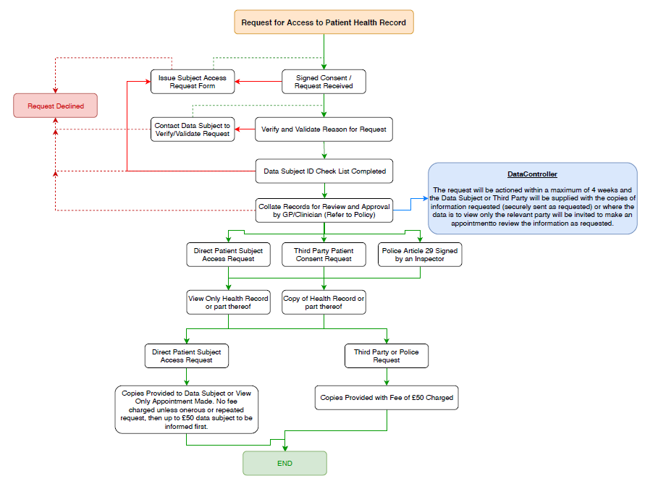

- Subject Access Request Form (Example)

